**Consciousness:** our awareness of ourselves and our environment.

**Preconscious:** something that is not in our conscious, but can be easily pulled into consciousness, such as memories.

**Unconscious:** according to Sigmund Freud, it’s a reservoir of mostly unacceptable thoughts, wishes, feelings, and memories. According to contemporary psychologists, it’s information processing of which we are unaware. **\*This is different than being knocked unconscious.**

**Nonconscious:** things happening in your body of which you are not aware, such as hormone secretion.

**Biological Rhythms:** the periodic physiological fluctuations our bodies go through.

**Annual cycles:** cycles that occur in our bodies on a yearly basis, such as SAD (Seasonal Affective Disorder – becoming depressed during the winter), or birds flying south for the winter and bears hibernating.

**28-day cycles:** cycles that occur every month. Ex. a woman’s menstrual cycle.

**Circadian rhythm:** the biological clock; regular bodily rhythms that occur on a 24-hour cycle, such as body temperature or wakefulness.

**Suprachiasmatic nucleus (SCN):** a pair of grain-of-rice –sized cell clusters in the hypothalamus that helps in waking up a person when it is activated by light-sensitive retinal proteins. It works with the pineal gland.

**Melatonin:** a sleep-inducing hormone. The SCN causes the brain’s pineal gland to decrease its production of melatonin in the morning or to increase it in the evening.

**Adenosine:** a neurotransmitter that causes drowsiness and the slowing of nerve cells. Caffeine is an antagonist that blocks the transmission of adenosine keeping us awake.

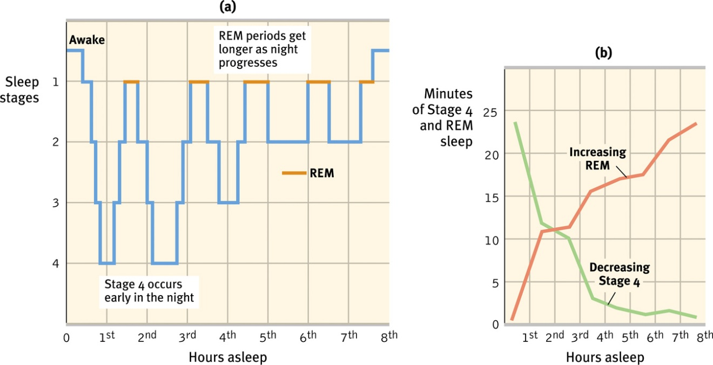**Sleep:** a periodic, natural loss of consciousness. Throughout the night, the body experiences many sleep cycles, each one lasting around 90 minutes. Each cycle has 5 stages (1, 2, 3, 4, REM)

**Beta waves:** waves of someone who is wide awake.

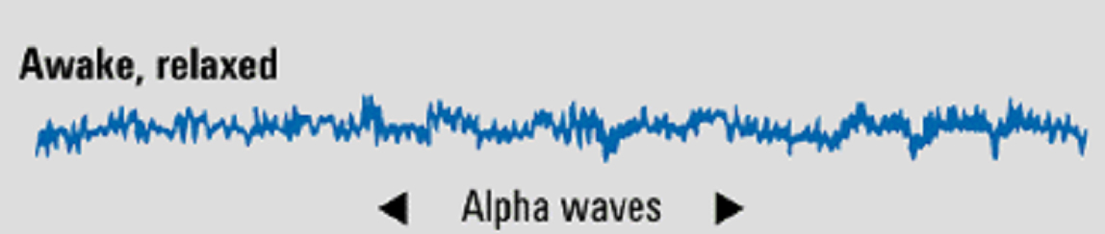**Alpha waves:** the relatively slow brain waves of a relaxed, awake state.

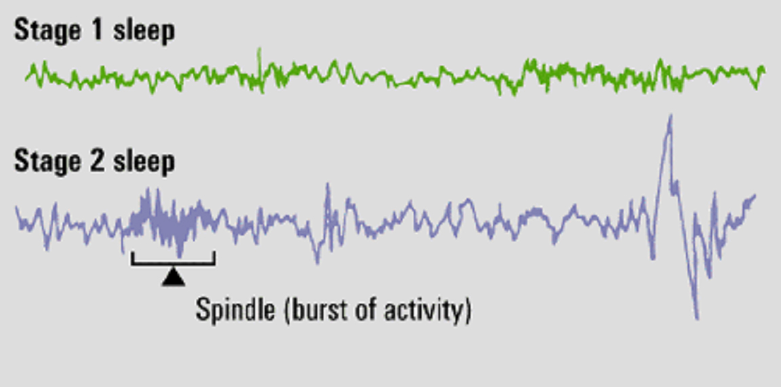**Stage one:** the first stage that lasts about 5 minutes, emit theta waves, may experience hallucinations and **hynagogic** sensations (feelings of floating or falling).

**Hallucinations:** false sensory experiences, such as seeing something in the absence of an external visual stimulus.

**Stage two:** the second stage that lasts for about 20 minutes, clearly asleep and experience **sleep spindles** (random bursts of activity).

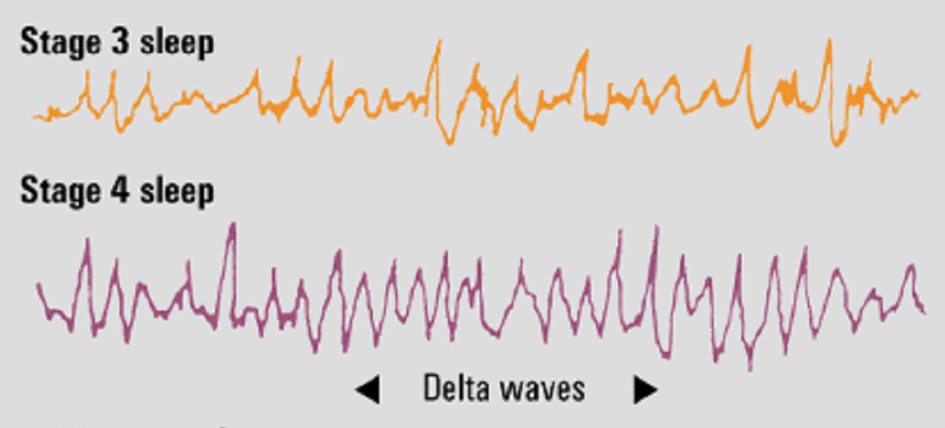**Stage three:** the third stage of sleep that is a transition stage into stage four, first emission of delta waves.

**Stage four:** the deepest stage of sleep in which it is hard to wake, lasts for about 30 minutes, emission of delta waves, sleep walking, bed wetting, etc. occur during this stage.

**Delta waves:** the larger, slow brain waves associated with deep sleep.

**REM sleep:** rapid eye movement sleep; a recurring sleep stage during which vivid dreams commonly occur. Also known as **paradoxical sleep** because the muscles are relaxed (except for minor twitches) but other body systems are active.

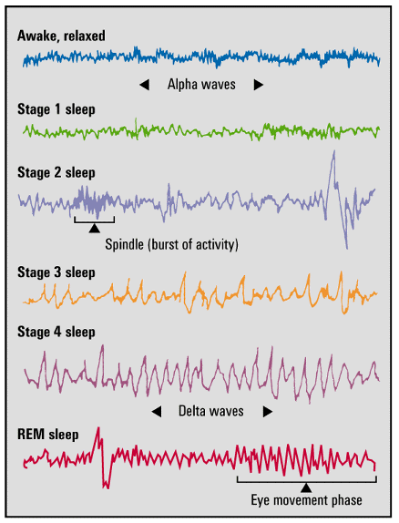

**NREM sleep:** non-rapid eye movement sleep; encompasses all sleep stages except for REM sleep.

**REM rebound:** the tendency for REM sleep to increase following REM sleep deprivation (created by repeated awakenings during REM sleep).

**Insomnia:** a sleep disorder in which a person has recurring problems in falling or staying asleep.

**Narcolepsy:** a sleep disorder characterized by uncontrollable sleep attacks. These attacks are usually caused by excitement. The sufferer may lapse directly into REM sleep, often at inopportune times.

**Sleep apnea:** a sleep disorder characterized by temporary cessations of breathing during sleep and repeated momentary awakenings. Sleep apnea is associated with obesity. It is suggested people lose weight to help curb the sleep apnea. Wearing an air pump while sleeping helps also.

**Night terrors:** a sleep disorder characterized by high arousal and an appearance of being terrified; unlike nightmares, night terrors occur during Stage 4 sleep, within two or three hours of falling asleep, and are seldom remembered.

**Dreams:** a sequence of images, emotions, and thoughts passing through a sleeping person’s mind during REM sleep.

**Lucid dreams:** a dream in which one is aware that one is dreaming.

**Manifest content:** the remembered story line of a dream (according to Sigmund Freud).

**Latent content:** the underlying meaning of a dream (according to Sigmund Freud).

**Dream theories:**

* **Freud’s wish-fulfillment theory:** dreams provide a “psychic safety valve” – expressing otherwise unacceptable feelings; contain manifest (remembered) content and a deeper layer of latent content (hidden meaning).
* **Information-processing theory:** dreams help us sort out the day’s events and consolidate our memories.
* **Physiological theory:** regular brain stimulation from REM sleep may help develop and preserve neural pathways.
* **Activation-synthesis theory:** REM sleep triggers impulses that evoke random visual memories, which our sleeping brain weaves into stories.
* **Cognitive theory:** dream content reflects dreamers’ cognitive development – their knowledge and understanding.

**Hypnosis:** a social interaction in which one person (the hypnotist) suggests to another (the subject) that certain perceptions, feelings, thoughts, or behaviors will spontaneously occur.

**Posthypnotic suggestion:** a suggestion, made during a hypnosis session, to be carried out after the subject is no longer hypnotized; used by some clinicians to help control undesired symptoms and behaviors.

**Posthypnotic amnesia:** a condition in which, in response to the hypnotist’s suggestion, the subject is unable to recall what happened while s/he was under hypnosis.

**Dissociation:** a split in consciousness, which allows some thoughts and behaviors to occur simultaneously with others.

**Hidden observer:** a part of a hypnotized person’s consciousness that remains aware of happenings even under hypnosis; Hilgard believes this is an example of dissociation.

**Social Influence Theory of hypnosis:** Hypnotic subjects may simply be imaginative actors playing a social role.

**Hilgard’s Divided Consciousness Theory of hypnosis:** Hypnosis is a special state of dissociated (divided) consciousness.

**Psychoactive drugs:** a chemical substance that alters a perceptions and moods.

**Tolerance:** the diminishing effect of a drug after repeated use that requires the user to take larger and larger does before experiencing the drug’s effect.

**Withdrawal:** the discomfort and distress that follow the discontinued use of a drug.

**Physical dependence:** a physiological need for a drug, marked by unpleasant withdrawal symptoms when the drug is no longer taken.

**Psychological dependence:** a psychological need to use a drug, such as to relieve negative emotions.

**Addiction:** compulsive drug craving and use, despite adverse consequences.

**Depressants:** drugs (such as alcohol, barbiturates, and opiates) that reduce neural activity and slow body functions.

**Korsakoff’s Syndrome:** a disorder that involves a severe B1 deficiency that causes dementia, brought on by alcoholism. Alcoholics tend to drink instead of eat.

**Barbiturates:** a major tranquilizer that depress the activity of the CNS, reducing anxiety but impairing memory and judgment.

**Benzodiazepines:** a minor/mild depressant that lowers anxiety and reduces stress.

**Opiates:** opium and its derivatives, such as morphine and heroin; they depress neural activity, temporarily lessening pain and anxiety.

**Stimulants:** drugs (such as caffeine, nicotine, and the more powerful amphetamines, cocaine, and Ecstasy) that excite neural activity and speed up body functions.

**Amphetamines:** drugs that stimulate neural activity, causing speeded-up body functions and associated energy and mood changes; also known as speed.

**Methamphetamine:** a powerfully addictive drug that stimulates the CNS, with speeded-up body functions and associated energy and mood changes; over time, appears to reduces baseline dopamine levels.

**Hallucinogens:** psychedelic (“mind-manifesting”) drugs that distort perceptions and evoke sensory images in the absence of sensory input.

**LSD:** a powerful hallucinogenic drug; also known as acid (lysergic acid diethylamide).

**Ecstasy (MDMA):**  a synthetic stimulant and mild hallucinogen that produces euphoria and social intimacy, but with short-term health risks and longer-term harm to serotonin-producing neurons and to mood and cognition.

**THC:** the major active ingredient in marijuana; triggers a variety of effects, including mild hallucinations.

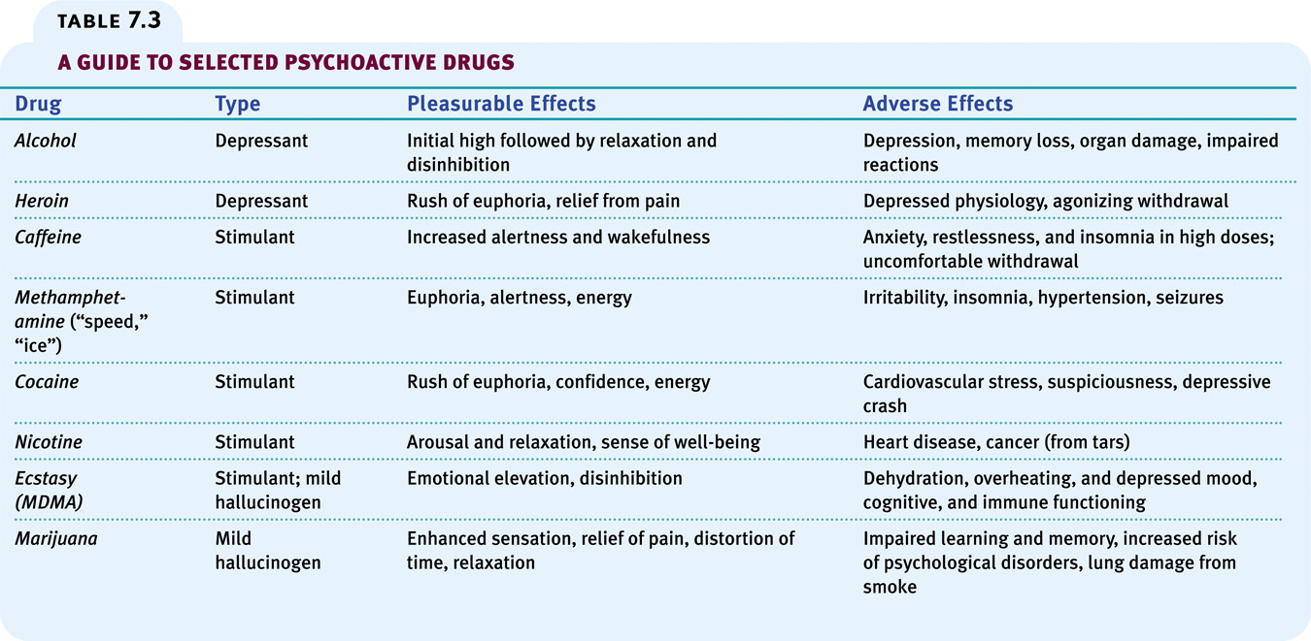

**Near-death experience:** an altered state of consciousness reported after a close brush with death (such as through cardiac arrest); often similar to drug-induced hallucinations.

**Monism:** a philosophical belief that the mind and body are different aspects of the same thing.

**Dualism:** a philosophical belief that the mind and body are distinct entities; the mind non-physical, the body physical.

**Bio-Psycho-Social influences on drug use:**

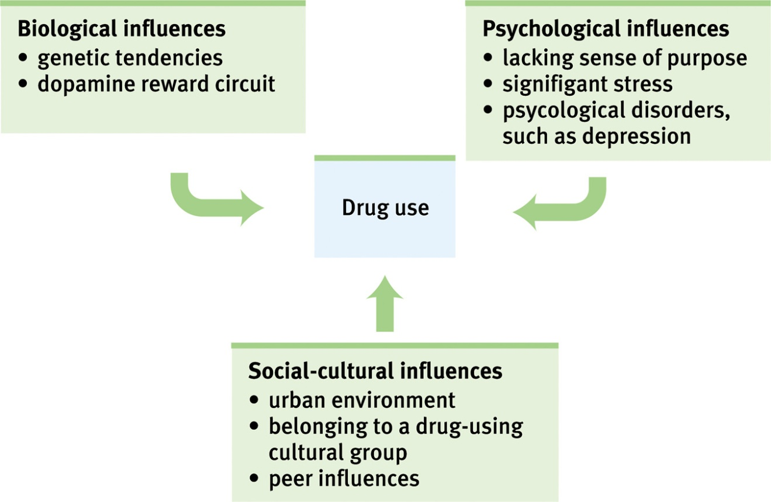

**States of Consciousness Key People:**

**Eugene Aserinsky:** discovered REM sleep when he hooked his son up to an EEG.

**Sigmund Freud:** wrote *The Interpretation of Dreams*. Believed dreams are “the royal road to the unconscious.” Said there were two levels of dreams: manifest and latent.

**Ernest Hilgard:** theorized that hypnosis induces a special state of dissociation, or divided consciousness.

**Anton Mesmer:** an Austrian physician who is credited with hypnosis’s modern popularity. He mistakenly thought he discovered an “animal magnetism”.

**Crick & McCarley:** said dreams were “housekeeping” for our brains.

**J. Allan Hobson:** proposed the activation-synthesis theory of dreaming (the personal way in which a dream organizes images).