**Motivation:**

**Motivation:** a psychological process that directs and maintains behavior towards a goal.

**Motive:** needs or desires that energize behavior.

**Instinct:** complex, inherited behavior patterns characteristic of a species that is unlearned.

**Imprinting:** an attachment to the first moving thing seen or heard after birth (for birds).

**Drive-reduction theory:** the idea that a physiological need creates an aroused tension state (a drive) that motivates an organism to satisfy the need.

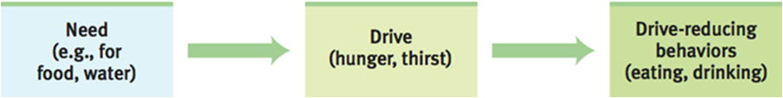

**Homeostasis:** a tendency to maintain a balanced or constant internal state; the regulation of any aspect of body chemistry, such as blood glucose, around a particular level.

**Need:** a necessity, especially a physiological.

**Desire:** something that is wanted, but not needed.

**Primary drive:** drives that are innate such as hunger, thirst, and sex.

**Secondary drive:** drives that are learned through conditioning such as working for money.

**Arousal:** the level of alertness, wakefulness, an activation caused by activity in the CNS.

**Yerkes-Dodson Law:** people perform best at a moderate level of arousal.

**Sensation seeking:** searching for a certain level of sympathetic nervous system of arousal.

**Incentive theory:** people are motivated by a desire to obtain external incentives.

1. **Incentive:** a positive or negative environment stimulus that motivates behavior.
2. **Primary incentives:** motivates behavior to satisfy a physiological need.
3. **Secondary incentive:** motivates behavior to satisfy a desire.

**Cognitive theory:** People are motivated as a result of their own thoughts, desires, goals, and expectations.

**Intrinsic motivation:** doing something because you generally like to do it.

**Extrinsic motivation:** doing something because of a promise of a reward or a threat of punishment.

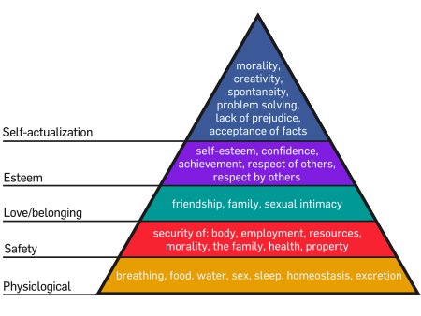**Overjustification effect:** the effect of promising a reward for doing what one already likes to do and then losing interest in it.

**Hierarchy of Needs:** Maslow’s pyramid of human needs, beginning at the base with physiological needs that must first be satisfied before higher-level safety needs and then psychological needs become active.

**Achievement:** the drive to succeed, especially when in competition.

**Sociobiology:** relates social behaviors to evolutionary biology.

**Hunger Motivation:**

**Glucose:** the form of sugar that circulates in the blood and provides the major source of energy for body tissues. When its level is low, we feel hunger.

**Lateral hypothalamus (LH):** the “on” button for eating. **\*Remember: If it is lesioned, people will not feel hungry and they will become little (LH).**

**Ventromedial hypothalamus (VMH):** the “off” button for eating. **\*Remember:If it is lesioned, people will not feel full and they will become very huge (VMH)**

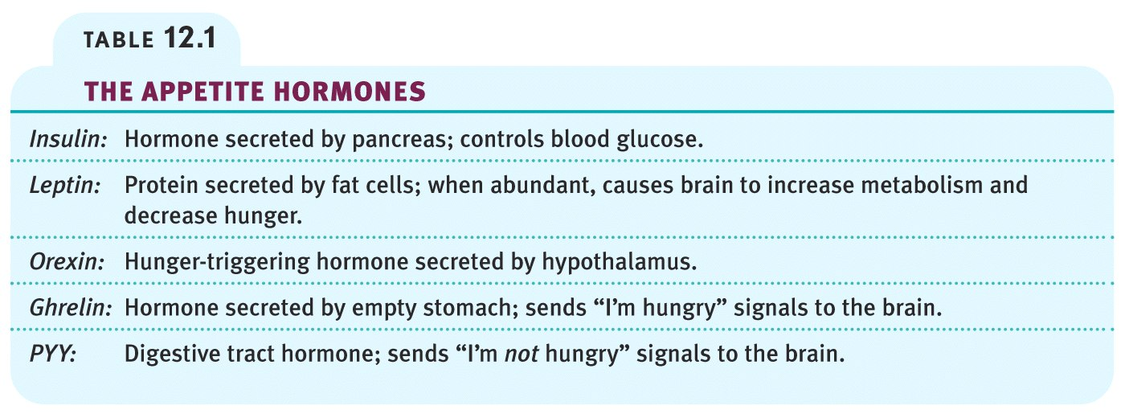**Appetite hormone:** controls the levels of glucose and the hunger of people.

**Set point:** the point at which an individual’s “weight thermostat” is supposedly set. When the body falls below this weight, an increase in hunger and a lowered metabolic rate may act to restore the lost weight.

**Basil metabolic rate:** the body’s resting rate of energy expenditure.

**Anorexia nervosa:** an eating disorder in which a person (usually an adolescent female) diets and becomes significantly (15 percent or more) underweight, yet, still feeling fat, continues to starve.

**Bulimia nervosa:** an eating disorder characterized by episodes of overeating, usually high-calorie foods, followed by vomiting, laxative use, fasting, or excessive exercise.

**Binge-eating disorder:** significant binge-eating episodes, followed by distress, disgust, or guilt, but without the compensatory purging, fasting, or excessive exercise that marks bulimia nervosa.

**Body Mass Index (BMI):** the percentage of a person’s body fat.

**Obesity:** a disorder characterized by being excessively overweight, usually considered to have a BMI of over 30%.

**Sexual Motivation:**

**Sexual response cycle:** the four stages of sexual responding described by Masters and Johnson – excitement, plateau, orgasm, and resolution.

**Refractory period:** a resting period after orgasm, during which a man cannot achieve another orgasm.

**Puberty:** the onset of sexual maturity.

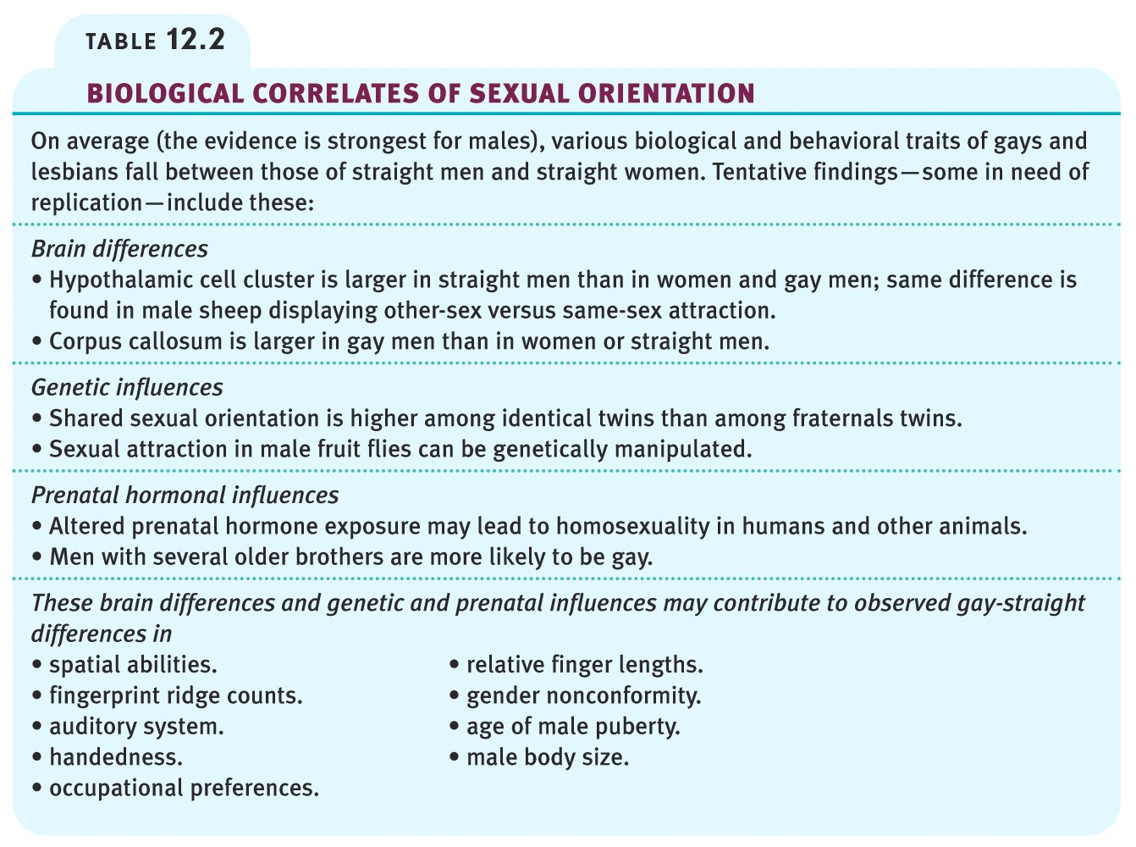**Estrogen:** sex hormone secreted in greater amount by females than males and contributing to female sex characteristics. In nonhuman female mammals, estrogen levels peak during ovulation, promoting sexual receptivity.

**Testosterone:** the most important of the male sex hormones. Both males and females have it, but the additional testosterone in males stimulates the growth of the male sex organs in the fetus and the development of the male sex characteristics during puberty.

**Sexual orientation:** sexual attraction toward members of either one’s own sex (homosexual orientation), both sexes (bisexual), or the opposite sex (heterosexual orientation).

**Emotion:**

**Emotion:** a response of the whole organism, involving (1) physiological arousal, (2) expressive behaviors, and (3) conscious experience.

**James-Lange theory:** our experience of emotion is our awareness of our physiological responses to emotion-arousing stimuli.

**Cannon-Bard theory (Thalamic Theory):** an emotion-arousing stimulus simultaneously triggers (1) physiological responses and (2) the subjective experience of emotion.

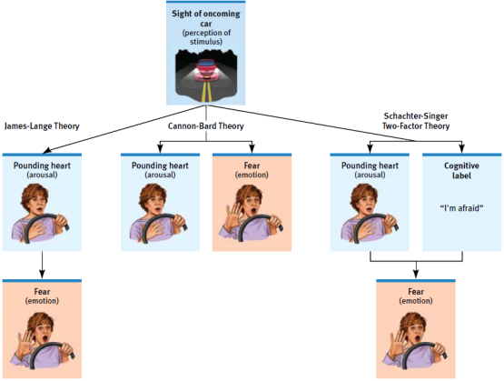**Schachter-Singer theory (Schachter-Two Factor):** to experience emotion one must (1) be physically aroused and (2) cognitively label the arousal.

**Cognitive-Appraisal Theory:** Our emotional experience depends on our interpretation of the situation we are in.

1. **Primary appraisal:** appraise a situation of whether or not you want to do something based on the consequences.
2. **Secondary appraisal:** deciding to do something based on the primary appraisal and your current emotion.

**Valence:** how pleasant something is.

**Feel-Good, Do-Good Phenomenon:** when we feel happy we are more willing to help others.

**Well-being:** self-perceived happiness or satisfaction with life. Used along with measures of objective well-being (for example, physical and economic indicators) to evaluate people’s quality of life.

**Tend and befriend:** a [behavior](http://en.wikipedia.org/wiki/Behavior) exhibited by some [animals](http://en.wikipedia.org/wiki/Animal), including [humans](http://en.wikipedia.org/wiki/Human), when under [threat](http://en.wikipedia.org/wiki/Threat). It refers to protection of [offspring](http://en.wikipedia.org/wiki/Offspring) (tending) and seeking out the [social group](http://en.wikipedia.org/wiki/Social_group) for [mutual defense](http://en.wikipedia.org/w/index.php?title=Mutual_defense&action=edit&redlink=1) (befriending).

**Adaptation-level phenomenon:** our tendency to form judgments (of sounds, of lights, of income) relative to a neutral level defined by our prior experience.

**Relative deprivation:** the perception that we are worse off relative to those with whom we compare ourselves.

**Behavioral medicine:** an interdisciplinary field that integrates behavior and medical knowledge and applies that knowledge to health and disease.

**Health Psychology:** a subfield of psychology that provides psychology's contribution to behavioral medicine.

**Facial feedback:** the effect of facial expressions on experienced emotions, as when a facial expression of anger or happiness intensifies feelings of anger or happiness.

**Catharsis:** emotional release. The catharsis hypothesis maintains that “releasing’ aggressive energy (through action or fantasy) relieves aggressive urges.

**Polygraph (lie detector machine):** a machine, commonly used in attempts to detect lies, that measure several of the physiological responses accompanying emotion (such as perspiration and cardiovascular and breathing changes).

**Stress:**

**Stress:** the process by which we perceive and respond to certain events, called stressors, that we appraise as threatening or challenging.

**Stressor:** anything that brings on the reaction to stress.

**Acute stressor:** fleeting, short-term stress.

**Chronic stressor:** persistent and enduring stress.

**Distress:** bad stress such as losing a job, a loved one, divorce, etc.

**Eustress:** good stress such as going on a vacation, the holidays, getting married, etc.

**Approach-approach:** the least stressful social conflict thatinvolves 2 options, only one of which you can choose. Ex. You are accepted to both Harvard and Dartmouth. Which do you chose?

**Avoidance-avoidance:** involves 2 negative options, one of which you must chose. Ex. mow the lawn or wash the dishes.

**Approach-avoidance:** involves whether or not to choose an option that has both a positive and negative consequence or consequences. You are both attracted and repelled by the same goal. Ex. you like to eat spicy food but it gives you heart burn.

**Multiple approach-avoidance:** most complex of the social conflicts that involves several alternative courses of action that have both positive and negative aspects. Ex. you only have a certain amount of money to spend on prom. Take a limo: spend most of your budget on the limo and have very little money left for a nice dinner; borrow your parent’s car: it can only fit one other couple and they can’t give it to you when you want it, but you save money; get a party bus: cheaper than a limo, but you don’t know all of the couples going.

**Glucocorticoids:** hormones that produce an array of effects in response to stress.

**Cortisol:** known as “the stress hormone” because it’s secreted in higher levels during the body’s [‘fight or flight’](http://stress.about.com/od/stressmanagementglossary/g/FightorFlight.htm) response to stress, and is responsible for several stress-related changes in the body. Small increases of cortisol have some positive effects: a quick burst of energy for survival reasons, heightened memory functions, a burst of increased immunity, lower sensitivity to pain, and helps maintain homeostasis in the body.

**General Adaptation Syndrome (GAS):** Selye’s concept of the body’s adaptive response to stress in three phases – alarm, resistance, exhaustion. **\*Remember: Selye’s three stages ARE (alarm, resistance, exhaustion) a GAS.**

1. **Alarm stage:** encounter threatening stimulus, fight or flight activated. If threat avoided, stage ends
2. **Resistance stage:** if the threat is not avoided there’s prolonged state of stress. Activation of stress cannot be kept up indefinitely.
3. **Exhaustion stage:** energy and strength are used up by maintaining resistance, can become vulnerable to illness, fatigue & injury.

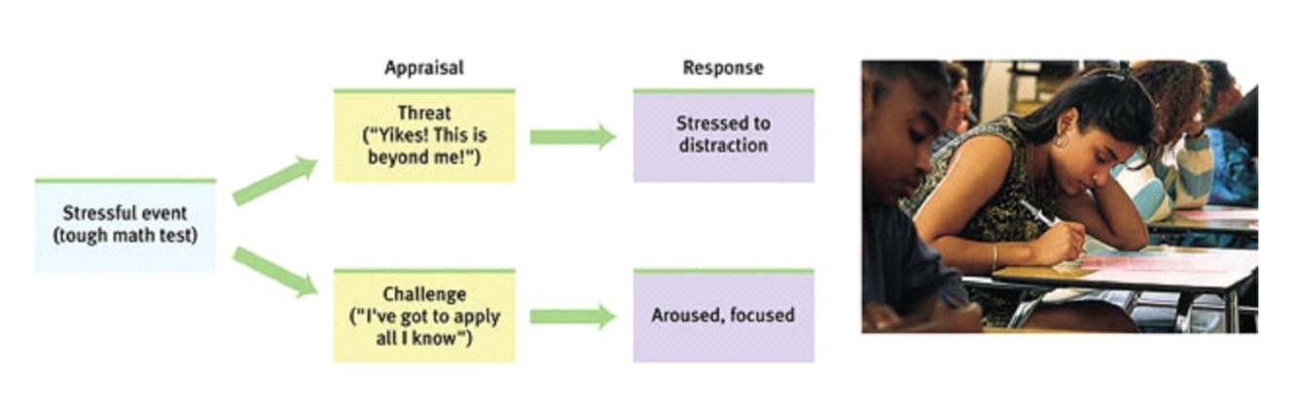**Cognitive appraisal of stress:** stress is not merely a stimulus or a response. It is a process by which we appraise and cope with environmental threats and challenges. When short-lived or taken as a challenge, stressors may have positive effects. However, if stress is threatening or prolonged, it can be harmful

**Primary appraisal of stress:** assess the potential threat or harm posed by the situation at hand.

**Secondary appraisal of stress:** if the event or situation is perceived as harmful or threatening, individuals assess their ability to cope with the event and the resources available to deal with the stressor.

**Coronary heart disease:** the clogging of the vessels that nourish the heart muscle; the leading cause of death in North America.

**Type A:** Friedman and Rosenman’s term for competitive, hard-driving, impatient, verbally aggressive, and anger-prone people.

**Type B:** Friedman and Rosenman’s term for easygoing, relaxed people.

**Type D:** the tendency to experience increased negative emotions across time and situations and tend not to share these emotions with others, because of fear of rejection or disapproval. The letter D stands for ['distressed'](http://en.wikipedia.org/wiki/Stress_(medicine)).

**Psychophysiological illness:** literally, “mind-body” illness; any stress-related physical illness, such as hypertension and some headaches.

**Psychoneuroimmunology (PNI):** the study of how psychological, neural, and endocrine processes together affect the immune system and resulting health.

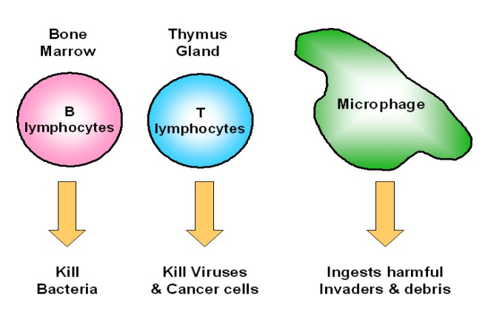**Lymphocytes:** the two types of white blood cells that are part of the body’s immune system; B lymphocytes form in the bone marrow and release antibodies that fight bacterial infections; T lymphocytes form in the thymus and other lymphatic tissue and attack cancer cells, viruses, and foreign substances.

**B lymphocytes:** fight bacterial infections.

**T lymphocytes:** attack cancer cells and viruses.

**Microphages:** ingest foreign substances.

**Problem-focused coping:** reducing stress by changing events that cause stress or by changing how we react to stress.

**Emotion-focused coping:** when we cannot change a stressful situation, and we respond by attending to our own emotional needs.

**Acute Stress disorder:** diagnosed with in the 1st month after exposure to a traumatic event. The person experiences depression and/or anxiety.

**Post Traumatic Stress disorder:** an anxiety disorder characterized by haunting memories, nightmares, social withdrawal, jumpy anxiety, and/or insomnia that lingers for four weeks or more after a traumatic experience.

**Motivation, Emotion, and Stress Key People:**

**Charles Darwin:** believed in natural selection and survival of the fittest.

**William James:** functionalist who looked at the instinctual functions of the body. Ex. why does the nose smell?

**William McDougall:** behavior is instinctual, such as aggression.

**Sigmund Freud:** personality is instinctual that stems from the unconscious.

**Konrad Lorenz:** studied the critical attachment period and imprinting in birds.

**Clark Hull:** drive reduction is a major cause of learning and behavior.

**David McClelland:** studied achievement motivation in which he said some people are more motivated by achievement than others.

**Abraham Maslow:** Humanist who developed the Hierarchy of Needs.

**Cannon-Washburn:** came up with the stomach contraction theory which states that we know we are hungry when our stomach contracts. In the notorious balloon study, Washburn trained himself to swallow a balloon which was attached to a tube, then the balloon was inflated inside of his stomach. When the balloon was inflated, he did not feel hungry. Later this theory was opposed by the fact that people whose stomach was removed still felt hungry.

**Y.C. Tsang:** removed rat stomachs, connected the esophagus to the small intestines, and the rats still felt hungry (and ate food).

**Paul Ekman:** conducted the most extensive research on the facial expressions of basic emotions, said there are 6 basic emotions and a universal “facial language”.

**Carol Izard:** isolated 10 emotions. Most of them are present in infancy, except for contempt, shame, and guilt.

**Hans Selye:** developed the General Adaptation Syndrome.

**Walter Cannon:** proposed that the stress response (fast) was a fight-or-flight response marked by the outpouring of *epinephrine* and *norepinephrine* from the inner adrenal glands, increasing heart and respiration rates, mobilizing sugar and fat, and dulling pain.

**Richard Lazarus & Susan Folkman:** cognitive appraisal of stress, how we respond to stress depends on 2 cognitive factors, primary and secondary appraisal.

**Kurt Lewin:** developed the types of social conflicts: approach-approach, avoidance-avoidance, approach-avoidance, multiple approach-avoidance

**Meyer Friedman & R.H. Rosenman:** studied health risks and personality types.

**Shelley Taylor:** tend and befriend behavior model.

**Thomas Holmes:** developed the stress scale, the Social Readjustment Rating Scale (SRRS), of 43 [stressful](http://en.wikipedia.org/wiki/Stress_(medicine)) life events that can contribute to [illness.](http://en.wikipedia.org/wiki/Illness)