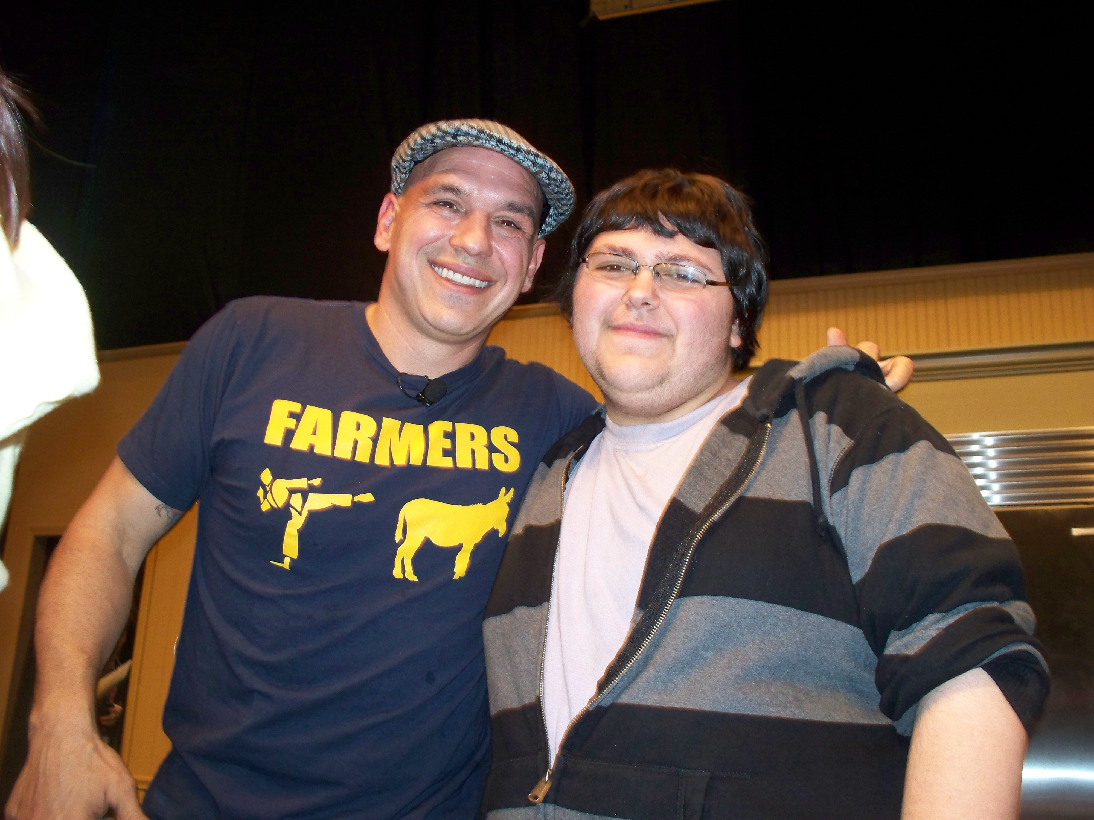
Jake at Food Show 2010 with Chef Michael Simon

