Intelligence Testing Review Sheet

Name | Origins of Intelligence | Name of Test | Summary of Test
Francis Galton  (Cousin of Charles Darwin) | Nature—Intelligence comes from good genes. He suggested that smart families should breed and believed in eugenics | None. His attempts were crude and unscientific | - He looked at successful European families in his book Hereditary Genius
Alfred Binet | Nurture-- Assumed low scoring kids could make gains with more remedial help and attention. | Binet’s Mental Ability Test | - Tested French school children to determine their strengths and weaknesses.  - Provided a mental age, showing the intellectual capabilities of the student.
William Terman | Nature—Also supported eugenics; encouraged low scoring groups to become sterilized. | Stanford-Binet | - Revised Binet’s Mental Ability Test  - First to adopt IQ score  - IQ= mental age/chronological age x100 (Note: this procedure is no longer used to calculate IQ)  - Only included verbal sections and were biased against non-English speakers.  - Tested immigrants (which led to quotas in immigration policy) and WWI recruits.
David Wechsler | Nurture—believed in a broad view of intelligence. “Intelligence is the aggregate or global capacity of an individual to act purposefully, to think rationally and to deal effectively with the environment.” | WAIS (for adults)  WISC (for children) | - Includes 11 sections, including verbal and performance subtests.  - Allowed non-English speakers to demonstrate their intelligence on the performance sections

Test Construction

- Standardization—Allows a researcher to make meaningful comparison by giving the test to a preselected group that is representative of the population. Tests are re-standardized in order to keep the average at 100. This enables the test scores to be placed on a normal curve, where the standard deviation is 15 IQ points.

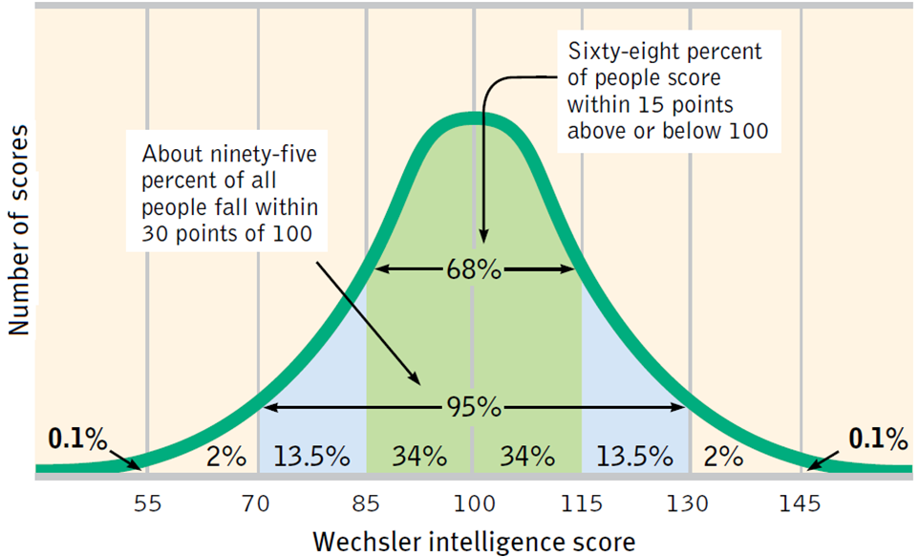

- Reliability-- A test produces consistent results (like Mr. Uliasz’s shoe size x10 IQ test). Can be tested by using:
- Split half—Divide test into two halves and compare the results (like odd v. even)
- Different tests—Take the test more than once and compare the results.

- Validity-- A test measures what it is supposed to measure.
- Content validity—extent that the test measures a subject, trait, or behavior (A math test measures math skills)
- Predictive validity—how well test predicts a future behavior or trait; used in aptitude tests, like the SAT that attempt to predict success on a criterion (GPA freshman year).
  - Note: as the range of scores narrows the predictive validity of a test weakens (football lineman and weight example).

